Second Life T-Shirt Request Form
Rev Mar 2017
All payments not made in-store must be made via PayPal. Once you submit your request, we will confirm the shirt size/color requested is available and send you an invoice via PayPal.

We cannot hold t-shirts. Once paid, your shirt will be held for shipment or pick-up in the store. Please pay as quickly as possible as sizes and quantities are limited. If you pay for a shirt and the size/color is no longer available, we can issue a refund or you can choose another color.

Thanks for your support!
Send form to contactus@secondlifeatlanta.org. Upon receipt of form, we will confirm if the color and sizes requested are available. If so, instructions for paying via PayPal will be sent to you.

Name: | Today’s Date
Mailing Address (where to mail your t-shirt): If it is a gift, please advise of recipient’s name.

Phone Number: | Email:

T-shirt Sizes:
- Women’s Cut: Medium (M), Large (L), X-Large (XL), 2XL. Note: They run 2 sizes small. More of a junior cut with smaller arm openings and curved cut.
- Unisex Cut: Medium (M), Large (L), X-Large (XL), 2XL. Note: They run fairly true to size. Not oversized
- All sizes may not be available in all designs. Quantities are limited for each size/color.
- Cost: $20 each for short-sleeve; $24 each for long-sleeve
- Shipping Costs: 1 or 2 shirts: $7.00 total via USPS Priority Mail. Savings may be available for additional purchases, but would need to be researched.

Please select one of the below options for receiving your t-shirts:
Pick-up in store (you have 7 calendar days to pick-up in-store once payment is made, or the t-shirt is considered a donation back to the store without a refund.

To be shipped (Shipping charge applies):

We are only able to print a select number of shirts per run, and cannot reorder until our inventory levels fall to a certain level. Please understand your color and size preference may not be available at this time. Thanks for your support and for helping us give homeless pets a second chance at life!

Women's - Bella by Canvas Brand - 100% Cotton
 | M | L | XL | 2XL  Size Charts for Women’s and Unisex Styles. All measurements are in inches and come directly from the manufacturer specifications.  Some shrinkage may occur after washing.
BODY WIDTH | 16.75 | 17.75 | 18.75 | 19.75
FULL BODY LENGTH | 26.75 | 27.25 | 28 | 28.5
SLEEVE LENGTH | 6.5 | 6.75 | 7.25 | 7.5
Unisex - Canvas Brand - 100% Cotton
 | M | L | XL | 2XL
BODY WIDTH | 20 | 22 | 24 | 26
FULL BODY LENGTH | 29 | 30 | 31 | 32
SLEEVE LENGTH | 8.63 | 9.13 | 9.63 | 10.25

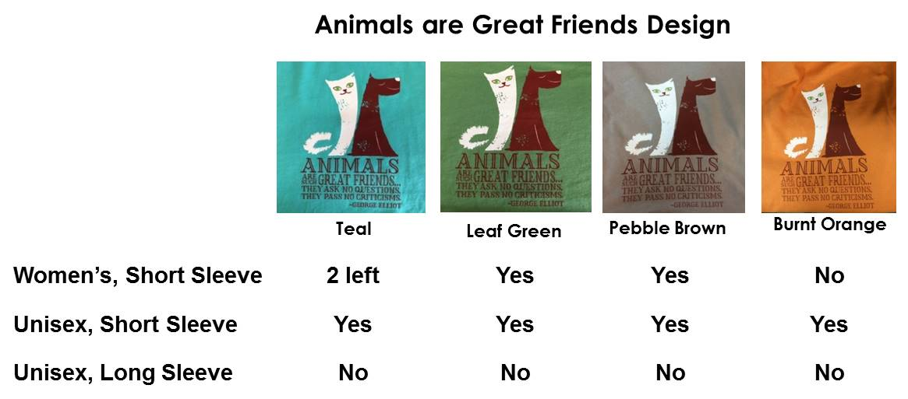
Logo on back of t-shirts

All t-shirts have a white Second Life logo on the back
T-Shirts | Color | Sizes Available | Quantity & Sizes To Order
Animals Are Great Friends | Choose Color(s) | Choose  Size(s) | Example:  1 Medium, 1 XL
WOMEN’S Cut | Aqua | M, L, XL, 2XL | Only size Large left.
WOMEN’S Cut | Leaf Green | M, L, XL, 2XL
WOMEN’S Cut | Pebble Brown | M, L, XL, 2XL
UNISEX Cut – Short Sleeve | Aqua | M, L, XL, 2XL
UNISEX Cut – Short Sleeve | Leaf Green | M, L, XL, 2XL
UNISEX Cut – Short Sleeve | Pebble Brown | M, L, XL, 2XL
UNISEX Cut – Short Sleeve | Burnt Orange | M, L, XL, 2XL

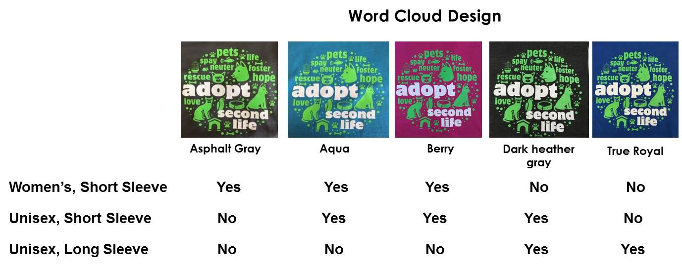

T-Shirts | Color | Sizes Available | Quantity & Sizes To Order
Word  Cloud | Choose Color(s) | Choose  Size(s) | Example:  1 Medium, 1 XL
WOMEN’S Cut | Asphalt Gray | M, L, XL, 2XL
WOMEN’S Cut | Aqua | M, L, XL, 2XL
WOMEN’S Cut | Berry | M, L, XL, 2XL
UNISEX Cut – Short Sleeve | Aqua | M, L, XL, 2XL
UNISEX Cut – Short Sleeve | Berry | M, L, XL, 2XL
UNISEX Cut – Short Sleeve | Dark Heather Gray | M, L, XL, 2XL
UNISEX Cut – Long Sleeve | Dark Heather Gray | M, L, XL, 2XL
UNISEX Cut – Long Sleeve | True Royal | M, L, XL, 2XL

